EEE521 Computer and Data Communication Networks
Preparatory notes

Local Area Networks and the Ethernet

A local area network (LAN) is a computer network that is designed for a limited geographic area such as a building or a campus. Although a LAN can be used as an isolated network to connect computers in an organization, most LANs today are also linked to a wide area network (WAN) or the Internet. There are different LAN technologies such as Ethernet, Token Ring, Token Bus, FDDI, and ATM LAN but Ethernet is by far the dominant one.

In 1985, the Computer Society of the IEEE started a project, called Project 802, to set standards to enable intercommunication among equipment from a variety of manufacturers. The project specified functions of the physical layer and the data link layer of major LAN protocols.The standard was adopted by the American National Standards Institute (ANSI). In
1987, the International Organization for Standardization (ISO) also approved it as an international standard under the designation ISO 8802.

The relationship of the 802 Standard to the traditional OSI model is shown below. The IEEE has subdivided the data link layer into two sublayers: logical link control (LLC) and media access control (MAC). IEEE has also created several physical layer standards for different LAN protocols

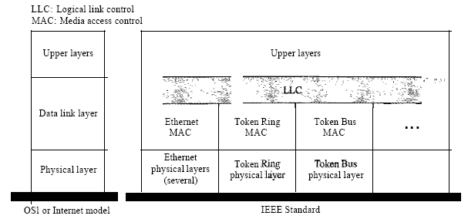

Logical Link Control (LLC)

In IEEE Project 802, flow control, error control, and part of the framing duties are collected into one sublayer called the logical link control. Framing is handled in both the LLC sublayer and the MAC sublayer. The LLC provides one single data link control protocol for all IEEE LANs. In this way, the LLC is different from the media access control sublayer, which provides different protocols for different LANs. A single LLC protocol can provide interconnectivity between different LANs because it makes the MAC sublayer transparent.

Media Access Control (MAC)

IEEE Project 802 has created a sublayer called media access control that defines the specific access method for each LAN. For example, it defines CSMA/CD as the media access method for Ethernet LANs and the tokenpassing method for Token Ring and Token Bus LANs. In contrast to the LLC sublayer, the MAC sublayer contains a number of distinct modules; each defines the access method and the framing format specific to the corresponding LAN protocol.

Frame Format
The Ethernet frame contains seven fields: preamble, SFD, DA, SA, length or type of protocol data unit (PDU), upper-layer data, and the CRC. Ethernet does not provide any mechanism for acknowledging received frames, making it what is known as an unreliable medium. Acknowledgments must be implemented at the higher layers. The format of the MAC frame is shown below.
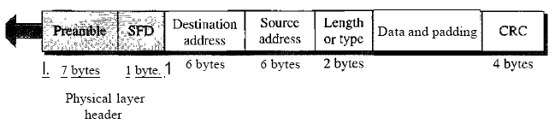Preamble. The first field of the 802.3 frame contains 7 bytes (56 bits) of alternating 0s and 1s that alerts the receiving system to the coming frame and enables it to synchronize its input timing. The pattern provides only an alert and a timing pulse. The 56-bit pattern allows the stations to miss some bits at the beginning of the frame. The preamble is actually added at the physical layer.

Start frame delimiter (SFD). The second field (l byte: 10101011) signals the beginning of the frame. The SFD warns the station or stations that this is the last chance for synchronization. The last 2 bits is 11 and alerts the receiver that the next field is the destination address.

Destination address (DA). The DA field is 6 bytes and contains the physical address of the destination station or stations to receive the packet.

Source address (SA). The SA field is also 6 bytes and contains the physical address of the sender of the packet.

Length or type. This field is defined as a type field or length field. The originalEthernet used this field as the type field to define the upper-layer protocol using the MAC frame. The IEEE standard used it as the length field to define the number of bytes in the data field. Both uses are common today.

Data. This field carries data encapsulated from the upper-layer protocols. It is a
minimum of 46 and a maximum of 1500 bytes.

CRC. The last field contains error detection information, in this case a CRC-32 is used.

Ethernet has imposed restrictions on both the minimum and maximum lengths of a frame

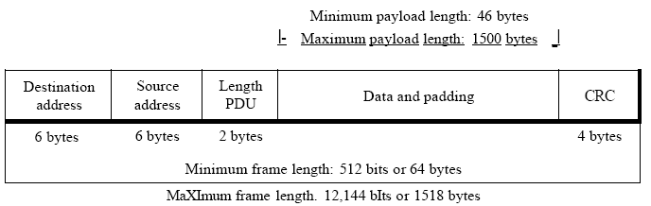

The minimum length restriction is required for the correct operation of CSMAlCD. Ethernet frame needs to have a minimum length of 512 bits or 64 bytes. Part of this length is the header and the trailer. If we count 18 bytes of header and trailer (6 bytes of source address, 6 bytes of destination address, 2 bytes of length or type, and 4 bytes of CRC), then the minimum length of data from the upper layer is 64 - 18 = 46 bytes. If the upper-layer packet is less than 46 bytes, padding is added to make up the difference.The standard defines the maximum length of a frame (without preamble and SFDfield) as 1518 bytes. If we subtract the 18 bytes of header and trailer, the maximum length of the payload is 1500 bytes. The maximum length restriction has two historical reasons. First, memory was very expensive when Ethernet was designed: a maximum length restriction helped to reduce the size of the buffer. Second, the maximum length restriction prevents one station from monopolizing the shared medium, blocking otherstations that have data to send

Standard Ethernet uses the I-persistent CSMA/CD. The acronym CSMA/CD signifies carrier-sense multiple access with collision detection and describes how the Ethernet protocol regulates communication among nodes. In other words, CSMA/CD is a set of rules determining how network devices respond when two devices attempt to use a data channel simultaneously (called a collision).
This standard enables devices to detect a collision. After detecting a collision, a device waits a random delay time and then attempts to re-transmit the message. If the device detects a collision again, it waits twice as long to try to re-transmit the message.

Physical Layer

The physical layer is dependent on the implementation and type of physical media used. IEEE defines detailed specifications for each LAN implementation. For example, although there is only one MAC sublayer for Standard Ethernet, there is a different physical layer specifications for each Ethernet implementations

The Ethernet has gone through four generations: Standard Ethernet (10 Mbps), Fast Ethernet (100 Mbps), Gigabit Ethernet (l Gbps), and Ten-Gigabit Ethernet (l0 Gbps). The most commonly installed Ethernet systems are called 10BASE-T and provide transmission speeds up to 10 Mbps. Devices are connected to the cable and compete for access using a Carrier Sense Multiple Access with Collision Detection (CSMA/CD) protocol. Fast Ethernet or 100BASE-T provides transmission speeds up to 100 megabits per second and is typically used for LAN backbone systems, supporting workstations with 10BASE-T cards. Gigabit Ethernet provides an even higher level of backbone support at 1000 megabits per second (1 gigabit or 1 billion bits per second). 10-Gigabit Ethernet provides up to 10 billion bits per second.

Topology is the shape of a local-area network (LAN). It describes pictorially the configuration or arrangement of a (usually conceptual) network, including its nodes and connecting lines. Topologies are either physical or logical. Ethernet uses topology to transfer the data.

There are four principal topologies used in LANs; Bus , Ring , Star and Tree topology

Bus topology: All devices are connected to a central cable, called the bus or backbone. Bus networks
are relatively inexpensive and easy to install for small networks. Ethernet systems use a bus topology.

Ring topology: All devices are connected to one another in the shape of a closed loop, so that each
device is connected directly to two other devices, one on either side of it. Ring topologies are relatively expensive and difficult to install, but they offer high bandwidth and can span large distances.

Star topology: All devices are connected to a central hub. Star networks are relatively easy to install and manage, but bottlenecks can occur because all data must pass through the hub.

Tree topology: A tree topology combines characteristics of linear bus and star topologies. It consists of groups of star-configured workstations connected to a linear bus backbone cable. These topologies can also be mixed. For example, a bus-star network consists of a high bandwidth bus, called the backbone, which connects collections of slower-bandwidth star segments.

Interconnection devices are used to interconnect LANs. There are physical-layer connectors such as optical repeaters, hubs and digital cross connects as well as data-link-layer such as LAN switches/bridges and frame relay switches.

Physical layer devices are used to increase the reach or geographic span of a physical network. As a signal propagates through a medium such as a coaxial cable, a twisted pair, or a fiber, it suffers from attenuation, i.e., signal strength loss. Beyond a certain distance, a signal has dropped below a strength threshold that makes it impossible to recover the information. A physical layer device such as a repeater is used to amplify the signal before it drops below the threshold The repeater does not process the content of the bits in anyway.

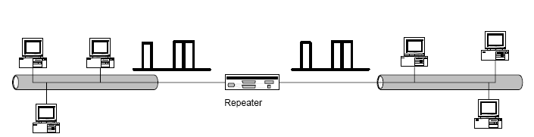

An Ethernet hub is also physical layer device, it serves solely as a conduit for passing packets from its input interfaces to its output interfaces. It broadcasts all information that it receives on its input ports to all of its output ports. It does not store any frames. The bits in a frame’s header are directly routed to all output ports without waiting for the remainder of the frame to be completely received at the input port. All links that connect devices, such are hosts and routers, to hubs, come in pairs, e.g., 10BaseT, 100BaseT; one pair is used for upstream traffic and the second pair is used for downstream traffic. Any data that is transmitted by a host on the uplink pair is looped back on the downstream pair. At the same time if another host transmits a frame on its upstream link, its bits will be broadcast to every port, these will be combined with the loopback transmissions on other downstream links, creating a collision. A host must therefore sense the downlink stream before commencing a transmission. But, as in any CSMA environment, collisions cannot be avoided since two devices could start their transmissions at the same time.

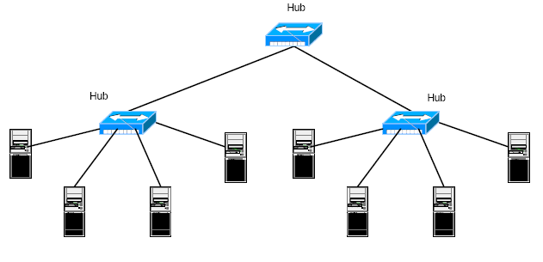

Bridges and LAN switches are devices that operate at the data link layer. They interconnect two or more LANs. A bridge was originally designed to provide a bridge between two different LAN technologies, e.g., an Ethernet LAN and a token ring LAN. However, over the past decade Ethernet has become the dominant LAN technology and we have seen the gradual demise of token ring LANs. Bridges evolved to not only bridge between two different protocols but to provide another option to hubs and repeaters for extending the size of an Ethernet network domain. Bridges are intelligent devices, that, contrary to hubs, isolate LAN segments thereby limiting the collision environments and
improving the overall throughput. By isolating LAN segments, one inherently obtains a more secure network in which data from one segment is not broadcast to another. A bridge is a store and forward device. Every frame is fully received before forwarding. Transmission on any outgoing link will only take place one frame at a time. Bridges cannot prevent collisions from occurring on an Ethernet segment, but they will not relay collided frames.

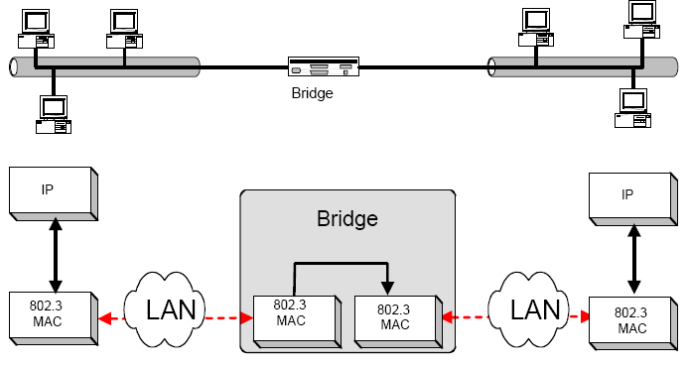

LAN switches are multi port (more than 4 port) bridges. LAN switches are touted by manufacturers as high throughput multi interface devices that can interconnect ports at a variety of speeds, e.g., 10M, 100M, 1G and 10Gpbs. They are also able to operate the links in full duplex mode if directly connected to a network device. Once the destination address has been processed the packet is forwarded to the appropriate output port where transmission can be commenced if the link is idle

